Module -1 (SDLC- Software Development life Cycle)

- What is software?

Software is a set of instructions, data or programs used to operate computers and execute specific tasks.

An operating system is a software program that serves as the interface between other applications and the hardware on a computer or mobile device.IP(internet protocol) is built into all major operating systems to allow computers to communicate over long distance network.Without the OS or the protocols built into it, it wouldn’t be possible to access a web browser.
Definition | Types | Functions | Durability | Nature | Examples
Collection of instruction that enables user to interact with the computer | System software ,programming software,application software | Provides instruction to the hardware | Software is durable and doesn’t wear out, but with the time, bugs may arises in the software which could be rectified. | Software is logical in nature. | Google chrome, Microsoft Excel,

There are two types of software:

System Software:
- System software controls a computer’s internal functioning. It helps the user, hardware, and application software interact and function with each other.System software act as a middle layer between the user and the hardware.

- It’s essential in managing the whole computer system- when a computer turns on, it’s the system software that is initially loaded into memory. Unlike application, system software is not used by end users. Instead ,it runs in the background of a device. Ex. Operating system, device driver such as keyboard or mouse..

Application software
- Application software is software that helps an end user to complete tasks such as doing research, taking notes, setting an alarm, designing graphics, or keeping an account log. Application software lies above the system software and is different from system software in that it’s designed for the end use and is specific in its functionality.
- This type of software is sometimes referred to as non-essential software because it’s installed and operated based on the user’s needs. Any application on a mobile phone is an example of application software.

- What are the types of applications?

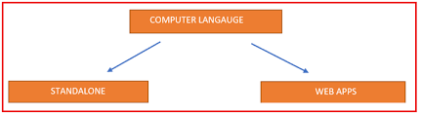

- A standalone application is a software program designed to be installed and run on a single computer or device. Standalone applications are usually developed for specific operating systems, such as Windows, mac-OS, or Linux. They are typically distributed as executable that can be downloaded and installed on a user's computer.
- On the other hand, a web application is a software program that runs on a web server and is accessed over the Internet using a web browser. Web applications are platform-agnostic, meaning they can be accessed from any device with a web browser, regardless of the operating system.
- As for which one is cheaper to develop, it depends on the specific requirements of the application and the available resources. Standalone applications can be more expensive to develop because they require more specific development expertise and may need to be developed for multiple platforms. However, web applications can also be complex and costly, especially if they require a lot of custom functionality or integration with other systems.

Examples:

Standalone applications : MS Paint, Calculators, Offline Card games, Tally Software, MS Word. These are all the example of standalone applications, which do not depend on any other service (database/any back-end servers or so). They act/work independently.
Client Server applications : Any banking software, Messenger applications (Skype, Microsoft teams, slack, Yahoo Messenger). These all are the examples of client server applications, they act as a client (user interface) for the servers (back-end).
Take an example of any banking applications : You installed any HDFC/AXIS bank app on mobile, now you do a login, do any transactions, view balance.
Anything you do on the app, is actually getting data from the servers, nothing is stored on your mobile app.

ALL INFORMATION IS STORED ON THE SERVERS, YOUR INSTALLED MOBILE APP IS JUST ACTING AS A CLIENT TO GET DATA FROM THE SERVERS.

Web applications : Any website can be termed as web application.

Example: same AXIS/HDFC bank website can be termed as web application, Amazon website, flipkart website, IRCTC website. These all are the examples of web applications.

In general, web applications are often considered more cost-effective to develop and maintain because they can be accessed from any device with a web browser and do not require separate installations on each device. However, standalone applications can also be a good choice for certain applications, such as those that require offline access or need to take advantage of specific hardware or software features that are not available in web browsers.

- What is programming ?

- A computer program consists of code that is executed on a computer to perform particular tasks. This code is written by programmers.
- Programming is the process of giving machines a set of instructions that describe how a program should be carried out. Programmers will spend their whole careers learning a variety of programming languages and tools so they can effectively build computer programs.
- Programmers will start by using a code editor or IDE to write what is called source code. This is a collection of code written in a programming language that other programmers can read.
- Source code needs to be converted into machine language so machines can understand the instructions and execute the program. This process of converting source code into machine language is known as compiling.
- Examples of compiled programming languages would be C and C++.
- There are other languages that do not use compilers. Instead, these languages will use an interpreter that will read and execute the code.
- Examples of interpreted programming languages would be JavaScript and PHP,Python.
- Once the code is executed, then the computer program can run. The different types of computer programs include Word processors, Database systems, video games, and websites.
- These computer programs allow us to interactive with different software devices and services like phones, websites, and the computers themselves.
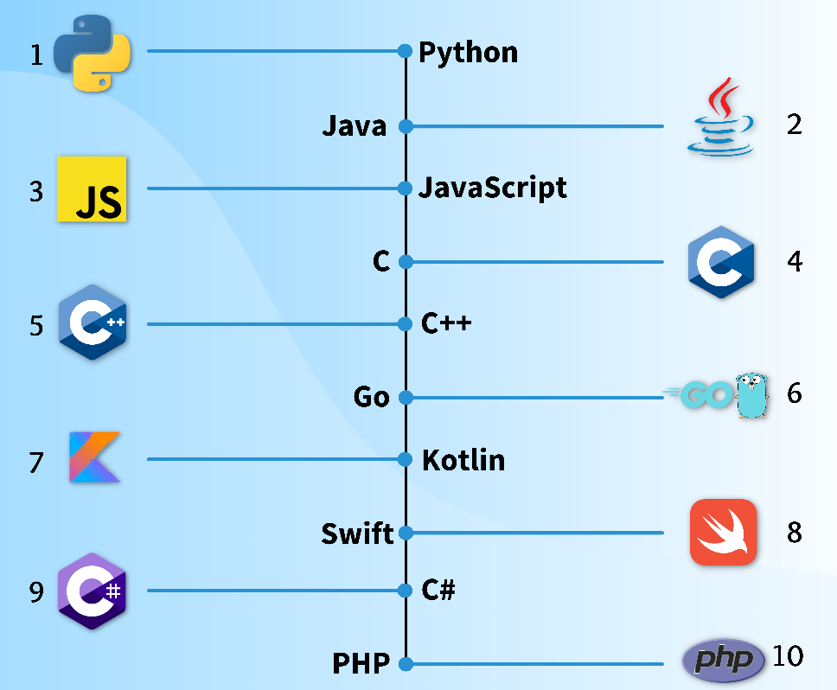
- What is python?

Python is a computer programming language often used to build websites and software, automate tasks, and conduct data analysis. Python is a general-purpose language, meaning it can be used to create a variety of different programs and isn’t specialized for any specific problems. This versatility, along with its beginner-friendliness, has made it one of the most-used programming languages today.

The name Python comes from Monty Python. When Guido van Rossum was creating Python, he was also reading the scripts from BBC’s Monty Python’s Flying Circus. He thought the name Python was appropriately short and slightly mysterious.

The programming language includes thousands of third-party modules available in the Python Package Index (PyPI). PyPI provides popular standards for different expertise, like Django for web development and NumPy, Pandas, and Mathplotlib for data science.

Why Python is popular ?

- Object-Oriented: Python was created with an Object-oriented programming approach which helps in writing clean and clear code. Object-oriented programming can be achieved through Python Class.
- Use of Interpreter: Python codes are interpreted line by line at a time using the Interpreter. This also helps in debugging.
- Free and Open-source: This is a free and open-source programming language so everyone can use it.
- Simple: It is simple to use as it is just like an English sentence resulting in fast coding and execution.
- Can be Integrated: It can be integrated with other programming languages like C, C++, Java, and many more. This will also teach you most of the programming concepts.
- Cross-platform: Python is a cross-platform programming language which means it allows you to use it on any platform like Windows, Linux, Mac, Unix, etc.
- Large library: Python’s ecosystem is large and growing, with a wide range of open-source packages and libraries. There are over 137,000 Python libraries.
- Elegant Syntax: Python has a simple syntax that improves readability and lowers code maintenance costs which makes code elegant and straightforward.

